Accessibility Action Plan FY25–26

AGL Energy Limited

# Table of Contents

Introduction 3

Executive Sponsor Message - Melinda Hunter, General Counsel & Company Secretary 3

Message from Hilary Thorpe, AGL Ability Chair & Head of Legal – Corporate 3

Our commitments 5

What is disability? 5

Our partnerships 5

AGL Ability 5

Our highlights FY23–24 7

Our people 7

Our Communities 9

Our Accessibility Action Plan FY25–26 11

Governance 15

Feedback 16

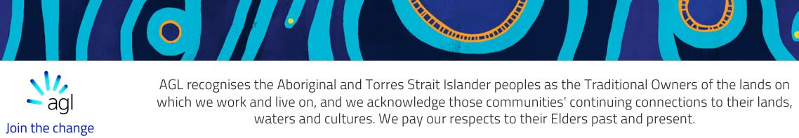

# Introduction

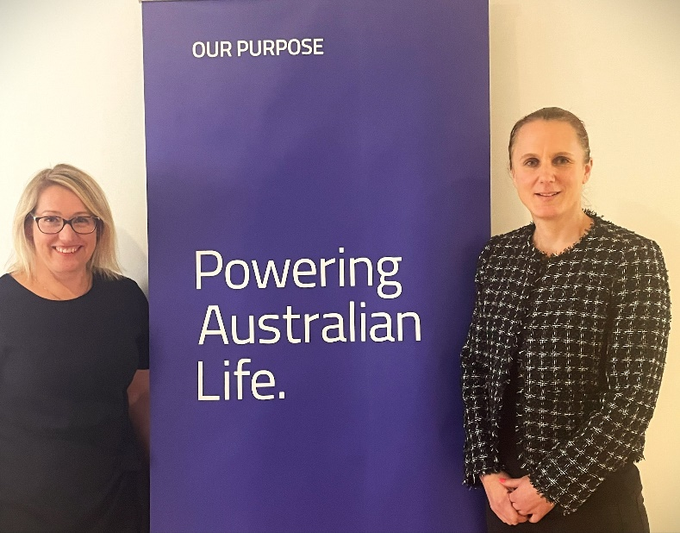

Melinda Hunter (left) and Hilary Thorpe (right)

## Executive Sponsor Message - Melinda Hunter, General Counsel & Company Secretary

We know that over 4.4 million people in Australia have some form of disability, which equates to nearly one in five people.[1] 2.1 million people of working age in Australia (15-64 years) have a disability[2], and at AGL that number is approximately 9%[3].

AGL’s purpose, Powering Australian Life, reflects our commitment to provide reliable, sustainable and affordable energy solutions for millions of homes and businesses as we play a leading role in Australia’s energy transition. It is therefore imperative that all of our customers can easily access our products and services regardless of their abilities.

At AGL we are guided by our three core values, one of which is Be Safe. Be Supportive. We are committed to creating a safe and supportive workplace for all of our employees, where everyone is valued, supported and has equal access to opportunities, our premises and our resources.

AGL has made significant progress in improving its disability access and inclusion maturity over the past few years. Since 2020, AGL’s Australian Disability Network Access and Inclusion Index score has improved significantly from our original score of 13%. However, there is still much more to do.

I’m delighted to be the Executive Sponsor of AGL Ability, AGL’s disability inclusion employee network, and look forward to championing AGL’s FY25-26 Accessibility Action Plan so that we can deliver on our ambitions and continue to build on the progress we have made to improve access and inclusion at AGL for our employees, customers and the wider community.

## Message from Hilary Thorpe, AGL Ability Chair & Head of Legal – Corporate

As the mother of a young child with a disability I am acutely aware of the need to improve access and inclusion in all aspects of Australian society so that everyone feels supported, valued for who they are and able to fully participate in all aspects of life. Large corporates, such as AGL, have an important role to play in ensuring that this happens.

I am honoured to be the Chair of AGL Ability and am extremely proud of the work that AGL has done over the past few years to make AGL more accessible and inclusive. The actions set out in the FY25-26 Accessibility Action Plan build on the work that we have done so far and have been carefully developed to drive further meaningful change within our organisation. I’m excited to see what we can achieve over the next two years.



# Our commitments

**AGL** is **committed** to:

* employing and supporting people with disability within our workplace and aims to increase our representation of people with disability at AGL by the end of FY26.
* supporting our customers with disability to ensure they can easily access AGL’s products and services regardless of their abilities.

We know that nearly one in five Australians (4.4 million people) live with disability – and not every disability is visible.

Disability inclusion is about understanding the relationship between the way people function and how they work, and making sure everybody has the same opportunities to participate in every aspect of life.

## What is disability?

AGL affirms the Australian Disability Network’s (ADN) statement that there are many kinds of disability and they can result from accidents, illness, environmental exposure or genetic disorders. Disability may affect mobility, the ability to learn, or ability to communicate. Some people may have more than one disability. Disability may be visible or invisible, ma be permanent or temporary and may have minimal or substantial impact on a person’s abilities. Although some people are born with disability, many people acquire disability.

People “are considered to have a disability if they have a limitation, restriction or impairment which has lasted, or is likely to last six months and restricts everyday activities”.[4]

## Our partnerships

ADN is a national, membership based, for-purpose organisation that supports organisations to advance the inclusion of people with disability in all aspects of business. AGL has been a member of ADN for over 10 years and became a gold member in 2022.

AGL committed to The Valuable 500 in 2020, making us the first Australian energy company to join the collective. The Valuable 500 is a global movement putting disability inclusion on the business leadership agenda. The movement is calling on 500 of the most influential business leaders and their brands to ignite systematic change by unlocking the business, social and economic value of the 1.3 billion people living with disabilities around the world.

## AGL Ability

AGL Ability, AGL’s disability inclusion employee network, was established in 2020. Its purpose is to create and foster a safe and supportive workplace for all employees, whether or not they have a disability.

AGL Ability is overseen by the AGL Ability Committee (Committee). The Committee comprises approximately 15 members representing AGL’s major business units, corporate functions, locations, roles and diversity streams. Whilst some Committee members identify as a person with disability, and other members are carers for people with a disability, all Committee members are passionate about ensuring that AGL is a disability confident workplace where everyone feels included, valued, supported and able to bring their whole selves to work.

The Committee aims to enhance disability awareness at AGL through communication and education and to improve AGL’s access and inclusion maturity in line with AGL’s Accessibility Action Plan. The Committee’s primary objectives are to:

* build awareness of the barriers in the workplace that impact on people with disability being able to participate in the workplace;
* enhance the skills of people leaders, and other key roles, to help support and develop employees with disability and create inclusive environments;
* facilitate an improved capacity to employ, develop and retain people with disability; and
* develop and maintain a workplace that is inclusive and engaging, with the right attitudes and capability towards accessibility.

The Committee’s Charter was updated in 2023 to ensure that it remains fit for purpose.

The Chair of the Committee sits on AGL’s Diversity and Inclusion Council (Council). The Council comprises the AGL Executive Team, Diversity & Inclusion leaders and the chairs of each of AGL’s six Diversity & Inclusion Committees. The Council acts as a consultation and advisory committee to drive AGL’s overarching D&I strategy and is the governing body of AGL’s Employee Networks. The role of the Council includes:

* sponsoring and role modelling AGL’s Values and Diversity and Inclusion Strategy across AGL’s business and operational sites;
* assisting in the development and execution of actions that foster a diverse and inclusion workplace; and
* monitoring the progress of diversity and inclusion actions that underpin AGL’s Diversity and Inclusion Strategy.

# Our highlights FY23–24

In FY23-24 we continued to make improvements in relation to inclusion and accessibility that impact our people, customers and the communities in which we operate.

## Our people

### Benchmarking ourselves

In FY23 and FY24 AGL benchmarked its access and inclusion maturity using ADN’s Access & Inclusion Index (Index). The Index is Australia’s national benchmarking instrument for disability workplace inclusion from which top employers for people with disability is determined. AGL first completed the Index in 2020 and scored 13%. Since that time AGL’s Index score has significantly improved due to a concerted effort to make improvements (including through the implementation of actions in our previous Disability Action Plans (now known as Accessibility Action Plans) across a number of areas, including IT and customer accessibility, leadership/training, the employee experience (recruitment/onboarding/reasonable adjustments/flexible working) and in relation to AGL’s physical premises. In both 2022 and 2023 AGL ranked seventh out of all of the companies that completed the Index and in 2023 AGL ranked first in the Electricity, Gas and Water Supply Industry category. Additionally, in:

* 2022, AGL ranked second in the Innovation category, fourth in Commitment and fifth in Information and Communication Technology; and
* 2023, AGL ranked first in Premises, third in Communications & Marketing and sixth in Commitment.

In 2023, Knowable Me, an organisation “founded to address the lack of available data and insights on the needs and preferences of people with disability”[5], mapped the ASX100 for their commitment to supporting people with a disability, ranking AGL in the top three ASX100 companies.

### Employees & recruitment

In FY23-24:

* we made a number of changes to our onboarding and recruitment practices to ensure that prospective and new employees are aware that they can ask for reasonable workplace adjustments;
* a number of employees completed Disability Confident Leadership training which is designed to assist leaders to confidently manage people with disabilities and promote an inclusive workplace;
* our Talent Acquisition team undertook Disability Confident Recruitment training;
* we updated our Diversity & Inclusion Policy, Code of Conduct and accompanying training modules to ensure that they include inclusive language and include examples involving people with disability;
* a change was made to our enterprise management system (Workday) so that the demographics of our workforce (including diversity metrics) can be formally tracked in real time;
* we developed an Event Accessibility Checklist as a resource to be used by employees to help them make meetings and events more accessible and inclusive; and
* we held various internal events to coincide with International Day of People with Disability and to showcase AGL’s access and inclusion journey to date.

## Our Offices and Sites

In September 2022, ADN conducted a Dignified Access Review of AGL’s Bayswater power station located in the Hunter Valley. The purpose of the review was to determine whether there are potential barriers for people with disability accessing and using this facility. ADN recommended a number of improvements to the facility for AGL to consider. AGL has implemented changes to the facility in light of ADN’s recommendations and has shared the learnings from this review, and ADN’s recommendations, across its sites.

ADN also conducted a Dignified Access Review of AGL’s Loy Yang power station located in the Latrobe Valley in early 2024. We have started to prepare a Loy Yang Accessible Action Plan to implement a number of ADN’s recommendations following this review.

In 2023 we conducted Dignified Access Reviews, using an ADN checklist, to evaluate, and improve, the accessibility of our sites and corporate offices, noting that all of AGL’s premises currently meet Disability (Access to Premises – Buildings) Standards 2010 minimum requirements. We have conducted access reviews of a number of our sites/offices and have started to implement improvements. We intend to complete these reviews and implement improvements in FY25.

We have also developed Accessibility Design Guidelines (Guidelines). These Guidelines exceed the standards set out in the Australian Building Code and are intended to guide designers to ensure they design our physical environments for people with disability, enabling them to access premises in a dignified, equitable way. We intend to use these Guidelines to fit out our new offices/sites and when we upgrade our existing offices/sites.

### Examples of new office wayfinder signage implemented in AGL’s Sydney and Melbourne offices in FY23-FY24:

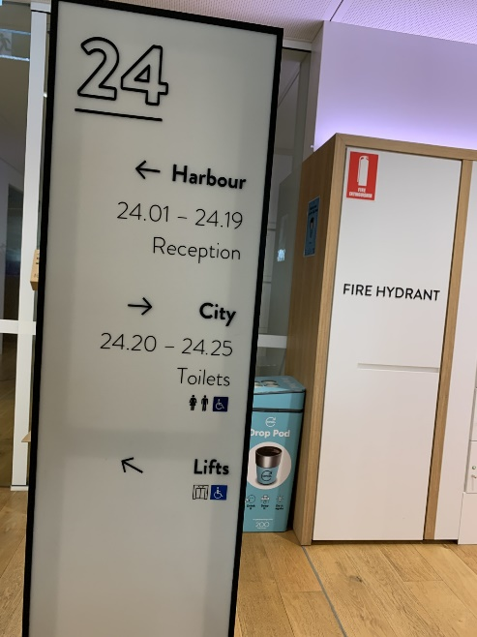 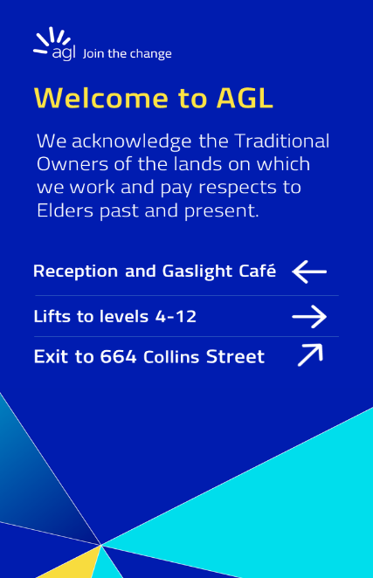

## Our customers

### Accessibility

AGL’s Customer Accessibility Working Group (CAWG) was established in 2023. The CAWG brings together subject matter experts from across our business to drive change, foster collaboration and help embed accessibility and inclusion into our customer processes. The purpose of the CAWG is to identify and implement practical solutions to AGL’s customers’ accessibility needs guided by ADN’s feedback on areas for improvement.

Monthly focus group meetings attended by AGL’s front-line customer service employees have also been established. At these meetings time is set aside to share insights into accessibility requests received from our customers with disability. Learnings are then shared with relevant functional teams.

In FY23-24 AGL continued to work on improving communications with its customers with disability, with a focus on making communications more accessible and improving energy literacy. A Digital Accessibility Toolbox has been developed which contains a wide range of resources and tools that our employees can use to make digital communications more accessible. In 2023, a number of employees across our customer markets, marketing, communications and digital teams completed ADN’s Accessible Communications training.

### Products & Technology

In 2023 we created a new role - “Digital Accessibility Lead” – who is responsible for embedding accessible practices in the build and maintenance of AGL’s digital products, including AGL’s website, intranet, online customer portals and phone apps, as well as coaching other AGL employees to uplift their accessibility knowledge and capabilities.

In October 2023, formal accessibility checks were introduced into AGL’s digital product delivery pipeline which are designed to capture potential accessibility issues before digital products are rolled out to customers. The Digital Accessibility Lead also runs regular accessibility audits on AGL’s major digital products to identify issues and to assist with their rectification.

An IT accessibility group has also been established to collaborate on IT/digital accessibility and a Technology Accessibility Guide has been developed and made available to employees via the Source (AGL’s intranet).

## Our Communities

### Mentoring and internships

In FY23-FY24 AGL continued its involvement in ADN’s Positive Action towards Career Engagement (PACE) Mentoring Program which matches mentors with jobseekers and university students with disability. In FY23-24, AGL employees mentored 19 students/jobseekers. Participation in the PACE Mentoring Program provides a number of benefits for mentors, including increased disability confidence, development of leadership skills and the privilege of helping to support the career aspirations of their mentees.

AGL hosted three paid interns in FY23-24 as part of ADN’s Stepping Into internship program (Internship Program) in engineering roles. This Internship Program is a paid internship that matches university students and job seekers with disability with roles in leading Australian businesses. It provides interns with valuable experience working in a large organisation and AGL employees with the ability to increase their disability confidence, improve their leadership skills and gain insight into how to best support employees with disability.

In FY24 we also provided work experience for two Muswellbrook High School students with disabilities at our Bayswater power station – in the Procurement team and the Electrical Workshop.

### Collaboration

We recognise the importance of connecting with other organisations championing disability inclusion to share knowledge and learnings and to discuss important matters (for example, the Disability Royal Commission’s Final Report). In FY23-24 AGL employees attended ADN’s Roundtable discussions and participated as a panellist at two ADN events (including the 2024 ADN annual conference) discussing disability employment targets. We also attended industry discussions on accessible workplaces. Members of the Committee also sat on a panel at the Responsible Investment Association Australasia annual conference in May 2024 discussing inclusive workplaces and presented on workplace adjustments at an ADHD conference in July 2023.

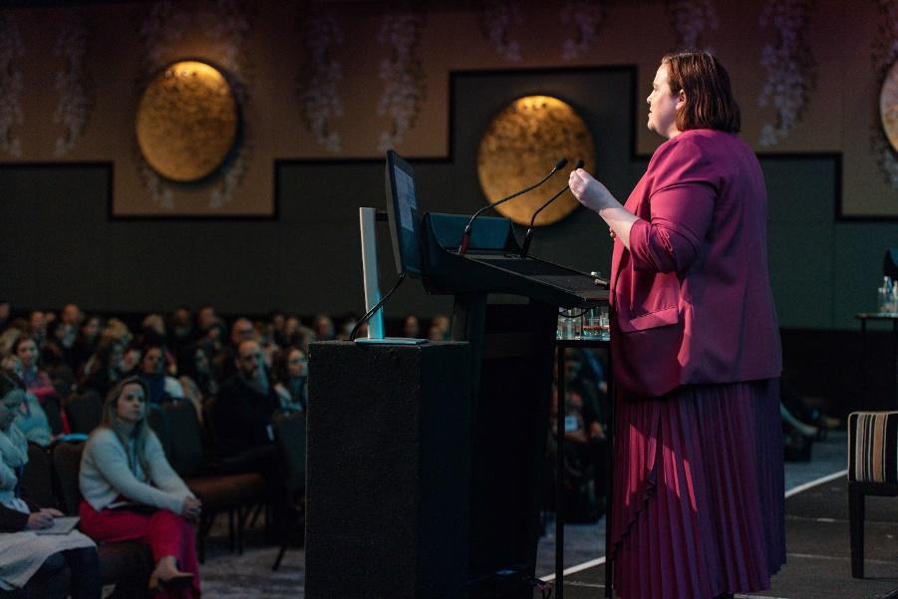

Natasha Legge-Wilkinson (a member of the AGL Ability Committee) speaking at an ADHD conference in July 2023.

### Other partnerships

In early 2024 AGL teamed up with ‘the Field’, an innovative jobs platform that aims to overcome barriers in employment for people living with disability by connecting jobseekers with inclusive employers[6]. This involves a 12 month pilot program within AGL’s Melbourne Technology Business Unit. As part of this, leaders will participate in additional inclusion and accessibility training. A comprehensive disability inclusion guide, “Hiring for Disability Inclusion” has been developed to ensure that leaders have access to relevant tools and resources to best support their teams.

In FY23-FY24 we continued to utilise local disability inclusive employment companies for some of our contracted services including grounds/vegetation maintenance, supply of goods, document scanning and shredding, catering and warehouse services.

# Our Accessibility Action Plan FY25–26

This plan sets out a number of actions that AGL will strive to achieve in FY25-26 to develop and improve its inclusion and accessibility maturity.

| Action | Measurement of Success | Accountability |
| --- | --- | --- |
| 1. **Inclusive Practices** | Foster Inclusive Workplace Culture. |  |
| A1. Review and improve the accessibility of AGL’s sites and corporate offices | * Complete Dignified Access Reviews of all of AGL’s sites and corporate offices and implement improvements identified. * Utilise the Accessibility Design Guidelines when fitting out AGL’s new Adelaide office, refitting AGL’s Melbourne office and any other works in our corporate offices and administration site locations. | Head of Property and Security Services/Property Projects Specialist |
| A2. Implement site specific improvements at AGL’s Bayswater power station | Implement the actions set out in the Bayswater Accessible Action Plan (Bayswater Plan) which was developed following the Australian Disability Network’s (ADN) Dignified Access Review of Bayswater power station in 2022 within the timeframes set out in the Bayswater Plan. | GM - Macquarie |
| A3. Identify and implement site specific improvements at AGL’s Loy Yang power station | * Develop a Loy Yang Accessible Action Plan (**LY Plan)** following ADN’s Dignified Access Review of the Loy Yang power station, with actions scoped and phased. * Implement actions set out in the LY Plan in accordance with the timeframes specified in the LY Plan. | GM - Loy Yang |
| A4. Deliver disability awareness and confidence training | * Roll out inclusive recruitment training at a minimum once every two years and build inclusive recruitment training into onboarding for Talent Acquisition Partners in the Talent Acquisition team. Use feedback from training to improve recruitment practices. * Run internal awareness sessions on accessibility and workplace adjustments - cohort to include members of the People and Culture and Injury Management Teams. | GM Talent, Capability & Inclusion/Diversity & Inclusion Consultant/Property Projects Specialist/Manager – Injury Management |
| A5. Share lessons learnt | Schedule regular meetings to discuss case studies and lessons learnt (on an anonymised basis so as not to identify any particular individual) in the recruitment, onboarding and provision of reasonable adjustments to people with disability - attendees to include P&C Business Partners, Injury Management team, the HSE team, Recruitment team, Talent & Acquisition team and Property & Facilities team. Track actions stemming from these meetings to ensure improvement and accountability. | GM Talent, Capability & Inclusion/Diversity & Inclusion Consultant |
| A6. Review of Reasonable Adjustment Guidelines | Review the Reasonable Adjustment Guidelines yearly as part of AGL’s annual policy review program | GM Talent, Capability & Inclusion/ Diversity & Inclusion Consultant |
| A7. Improve technology accessibility | Develop and implement a process to ensure that digital accessibility is considered when procuring new products and services which have a digital component. | Chief Information Officer/GM Procurement and Property |
| A8. Review and improve procurement processes around disability inclusion | Engage directly with suppliers and partners about AGL’s accessibility requirements and amend AGL’s Supplier Registration form to obtain information about suppliers and partners’ access and inclusion activities and the accessibility of their products and services. | Head of Procurement Operations/Contract Managers |
| B. Inclusive Leadership | Leveraging diversity of thinking is critical to decision making. Our leaders’ role model the change required. |  |
| B1. Deliver disability awareness and confidence training | Implement a regular leadership disability awareness training program and provide resources to managers and people leaders on supporting team members with a disability. | GM Talent, Capability & Inclusion/Diversity & Inclusion Consultant |
| B2. Engage disability inclusion leaders | Maintain an active cohort of Disability Inclusion Leaders/Champions from across the business and review membership annually. Support leaders’ engagement and impact through role description, and scheduled connection and sharing of lessons learnt. | GM Talent, Capability & Inclusion/Diversity & Inclusion Consultant |
| B3. Continue with disability internship program | Provide paid internship opportunities for people with disability, supported by leaders competent in disability improvement (including those who attended disability confident training). Obtain feedback from interns and leaders to inform program improvements. | Disability inclusion leaders |
| B4. Participate in ADN’s PACE mentoring program on an annual basis | Participate in ADN’s PACE mentoring program on an annual basis. Obtain feedback from mentees and mentors to inform future improvements. | AGL Ability Chairperson and Committee |
| 1. **Data & Insights** | Data intelligence and best practice benchmarks inform D&I priorities and program design. |  |
| C1. Close the gap between employees anonymously identifying with disability and those willing to note in Workday (i.e not anonymously) that they have a disability | Undertake initiatives to encourage employees to voluntarily update their demographic information (including identifying if they have a disability) in Workday. | GM Talent, Capability & Inclusion/Diversity & Inclusion Consultant |
| C2. Determine % of Leaders with Disability | Implement a mechanism for collecting and collating information regarding levels of seniority of employees with disability. | GM Talent, Capability & Inclusion/Diversity & Inclusion Consultant |
| C3. Benchmark AGL’s access and inclusion maturity | Participate in ADN’s Access and Inclusion Index at least once every two years and maintain our top 10 ranking of companies participating in the Index. | GM Talent, Capability & Inclusion/Diversity & Inclusion Consultant |
| C4. Data analysis | Collate and analyse:   1. feedback data received from employees (e.g. from onboarding, employee surveys, workplace adjustment requests etc); and 2. customer disability inclusion and accessibility feedback (e.g from customer surveys and frontline Customer Solutions agents etc),   and identify common themes, and share lessons learnt amongst, in relation to:   * (a) above, the Recruitment team, HSE team, Injury Management team and P&C Business Partners; and * (b) above, the frontline Customer Solutions agents, Digital Accessibility Lead and the Talent Acquisition team (as applicable),   escalate issues and identify actions to resolve such issues. | GM Talent, Capability and Inclusion/Diversity & Inclusion Consultant/Chief Customer Officer/Chief Technology Officer/Digital Accessibility Lead |
| 1. **Engage Inside and Out** | Demonstrating our commitment to improving accessibility for our customers and communities |  |
| D1. Improve accessibility in relation to AGL’s products and services | * Identify (including key interactions between customers and AGL where accessibility can be improved. Develop and implement an action plan to improve accessibility in these areas. * Establish a formal process for consulting with a panel of people with disability at the design stage for new products and services. | GM Product and Portfolio/Customer Advocate |
| D2. Implement accessibility training | * Continue with the implementation of a tailored six-monthly accessibility training program for Customer Markets employees (including product owners, business owners, business analysts, designers, developers, quality testers, content producers and marketing consultants) to uplift their accessibility knowledge and seek feedback from attendees following such training as to whether they have improved accessibility confidence. * Commence the roll out of tailored accessibility training for communication and marketing personnel once the Customer Markets training has been completed. * Develop and publish accessibility guides on the Source. | Chief Technology Officer/Digital Accessibility Lead/GM Product and Portfolio |
| D3. Improve the accessibility of AGL’s customer and outward facing communications | * Progressively: * move away from using pdf for new customer and outward facing communications; * add accessible versions of pdf documents on AGL’s website – when implementing this change documents will be prioritised based on their volume of use and level of importance.   Aim to become WCAG 2.2 Level AA compliant. | Chief Technology Officer/Digital Accessibility Lead/GM Product & Portfolio |
| D4. Support companies who employ people with disabilities | Identify companies that employ people with disability to engage for tenders and quotes for work we externally source and engage such companies where they are the preferred vendor. | AGL Contract Managers |

# Governance

The Committee has overall responsibility for the delivery of AGL’s Accessibility Action Plan. The Committee is supported by the Executive Sponsor of AGL Ability, and a number of other people and teams as set out in the diagram below.

AGL’s Accessibility Action Plan was developed by the Committee in conjunction with the Diversity and Inclusion team and key stakeholders within AGL. This plan has been endorsed by the Executive Sponsor of AGL Ability and the members of the Executive Team who are responsible for particular action items. The plan also forms part of AGL’s overall D&I Strategy which is endorsed by the AGL Board.

The Committee reviews progress against each action item in the Accessibility Action Plan on a three to six monthly basis to ensure that items are being progressed and are on track for achievement during FY25-26. An update on progress is also provided to the Executive Sponsor of AGL Ability and the Diversity and Inclusion Council on a periodic basis.

We update our people, customers and communities on progress against the action items in our Accessibility Action Plan. We will benchmark this progress every two years using ADN’s Access and Inclusion Index.

# Feedback

## Contact Us

We value input from our people, customers, shareholders and communities and welcome any feedback and suggestions on the accessibility of our products and services and our FY25-26 Accessibility Action Plan. We especially welcome feedback from those with lived experience of disability.

### Email

Online enquiries form: [agl.com.au/contact-us](http://www.agl.com.au/contact-us)

Phone: 131 245 (available 24/7). If you are deaf or hard of hearing, or have difficulty speaking, you can use the National Relay Service.

### Write to us

AGL Customer Advocate  
Locked Bag 14120   
MCMC VIC 8001

### Website

[agl.com.au](http://www.agl.com.au)

## Alternative Access Formats

Our FY25-26 Accessibility Action Plan is available in standard and Easy Read versions at [agl.com.au](http://www.agl.com.au).

If you need an alternative format, email [ability@agl.com.au](mailto:ability@agl.com.au). Or call 131 245.

1. [www.aihw.gov.au/reports/disability/people-with-disability-in-australia/contents/people-with-disability/prevalence-of-disability](http://www.aihw.gov.au/reports/disability/people-with-disability-in-australia/contents/people-with-disability/prevalence-of-disability)
2. <https://australiandisabilitynetwork.org.au/resources/disability-statistics/#:~:text=Over%204.4%20million%20people%20in,with%20disability%20increases%20with%20age>.
3. AGL Flexibility + Diversity and Inclusion Survey 2022 results.
4. [Definition of disability | Australian Public Service Commission (apsc.gov.au)](https://www.apsc.gov.au/working-aps/diversity-and-inclusion/disability/definition-disability)
5. [ASX100 Insights (knowable.me)](https://knowable.me/asx100_insights)
6. <https://www.thefield.jobs/Job/Home>